

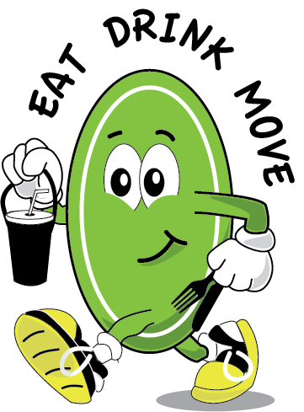



 **EAT...**

**Keep yourself nourished**

**Eating well in hospital is an important part of your recovery process**

**If you are concerned about your diet, how you are eating or if you need help of advice, please ask!**

**If your appetite is poor:** fd01226_[1]j0232868[1]

* Try to eat something at each mealtime; there is a wide choice on the menu
* If you don’t feel like anything from the menu, we will offer you an alternative
* Try some toast, soup or a milky drink and a pudding
* Eat ‘little and often’, try to have snacks and milky drinks between meals – there are snacks available on all our wards

**If your visitors want to bring food in for you,** the following snacks would be suitable to keep in your bedside locker: **Please ask if you need more information**

* Small quantities of fresh or dried fruit
* Individual cartons of fruit juice (that do not need to be kept in the fridge)
* Biscuits / individually wrapped cakes
* Sweets, chocolate

**Wash your hands! Good hygiene is very important**

* Make sure you wash your hands before you eat
* If you can’t get to the bathroom, ward staff will offer you hand wipes to use before meals



 **DRINK...**

**keep well hydrated**

**It is important to drink plenty of fluid to keep well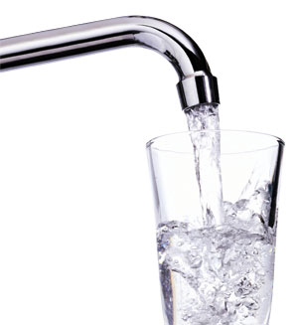**

**You might need more drinks in hospital than you usually have at home, for example if you are losing fluid or if you have a temperature**

**Try to have 10 cups of fluid a day unless you are told to limit your fluid intake**

**Make sure your drink is in reach or ask us to pass your drink if you can’t reach it**

**Try and have a drink every time you are offered one from the trolley. Have tea, coffee, milk, or soft drinks**

**Have water from the water jug too, and ask us to refill your water jug if you need more**

**If you are not drinking well keep sipping drinks throughout the day**

**Try milky drinks if you are not eating well to give you protein and energy as well as fluid.**

**C:\Documents and Settings\reillyh\Local Settings\Temporary Internet Files\Content.IE5\O7Q9ABUD\MC900293200[1].wmf**



 **MOVE...**

**stay active**

**Rest is important when you feel unwell, but keep moving too, in whatever way you can so you don’t lose fitness and strength**

**Work with your Physiotherapist, Occupational Therapist and the ward staff to get yourself up and about**

**Ask us to help if you need it. You might need help or walking aids to walk safely**

**Everyone is different, but try to keep active in whatever ways are safe for you:**

* **Get up and get dressed every day in your own clothes if you can. It makes you feel ‘more like yourself’ and encourages you to be more mobile on the ward**
* **Ask your relatives to bring in comfortable clothes, footwear and walking aids**
* **Walk around the ward when safe to do so**
* **Walk to the food trolley to choose your meals**
* **Walk with your relatives when they visit**
* **Try to do 900 steps as day if you are able**

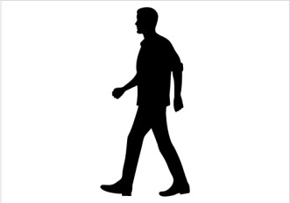



**EAT...**

**DRINK...**

**MOVE...**

**To help you feel better in hospital**

**Benefits for all……**

**Eating well, drinking fluids and being active can:**

**Help reduce your risk of complications**

**Help you to feel better sooner**

**Help you to be ready to leave hospital sooner**





 **MOVE...**

**stay active**

**Did you know……….?**

Rest is important when you feel unwell, but did you know that many patients in hospital are active for only a few minutes each day?

**This can lead to increased risk of…..**

Blood clots

Pneumonia 

Pressure sores

Falls

Spending longer in hospital

Hospital acquired infections

**What is the Solution……?**

**STAY ACTIVE as much as you can**

**What can you do?**

Everyone is different, but try to keep active in whatever ways are safe for you:

* Work with your Physiotherapist, Occupational Therapist and the ward staff to get yourself up and about
* Get up and get dressed every day in your own clothes
* Walk around the ward when safe to do so
* Walk to the food trolley to choose your meals
* Walk with your relatives when they visit
* Ask your relatives to bring in your clothes, footwear and walking aids

**What will we do?**

* Advise you how to be active and independent on the ward
* Provide you with a walking aid and equipment if you need it.
* Help you to be mobile if you need support or assistance



 **EAT...**

**Keep yourself nourished**

**Eating well in hospital is an important part of your recovery process.**

There is a varied choice of meals available every day, including options for vegetarian diets, cultural needs and special dietary needs. Ask your nurse for more information.

You may also be referred to a Dietitian if you need advice or support with a special diet or if you are having difficulty eating enough.

You may be referred to a Speech Therapist if you are having problems with swallowing.

**If you are concerned about your diet or how you are eating, please ask!**

**Even if your appetite is poor:**

* Try to eat something at each mealtime; there is a wide choice on the menu;
* If you don’t feel like anything from the menu, we will offer you an alternative. Try some toast, soup or a milky drink and a pudding.
* at ‘little and often’, try to have snacks and milky drinks between meals – there are snacks available on all our wards.

fd01226_[1]j0232868[1]

**If your visitors want to bring food in for you,** the following snacks would be suitable to keep in your bedside locker:

* **Small quantities of fresh or dried fruit**
* **Individual cartons of fruit juice (that do not need to be kept in the fridge);**
* **Biscuits / individually wrapped cakes;**
* **Sweets, chocolate.**

****Your ward will have a copy of the guidelines on bringing food into hospital if you need more information

**Wash your hands!**

**Good hygiene is very important.**

* Make sure you wash your hands before you eat;
* If you can’t get to the bathroom, ward staff will offer you hand wipes to use before meals.